COMPETITOR WEBSITE ANALYSIS

Sushi Haus is a Japanese restaurant in Anna Nagar and its website is taken for competitive analysis in order to find out the difference in visual design between “Sushi Haus” and “Fresh off the boat”. The analysis is based on the design principles and how effectively they have been used in each page of their website.

1.HOME PAGE:

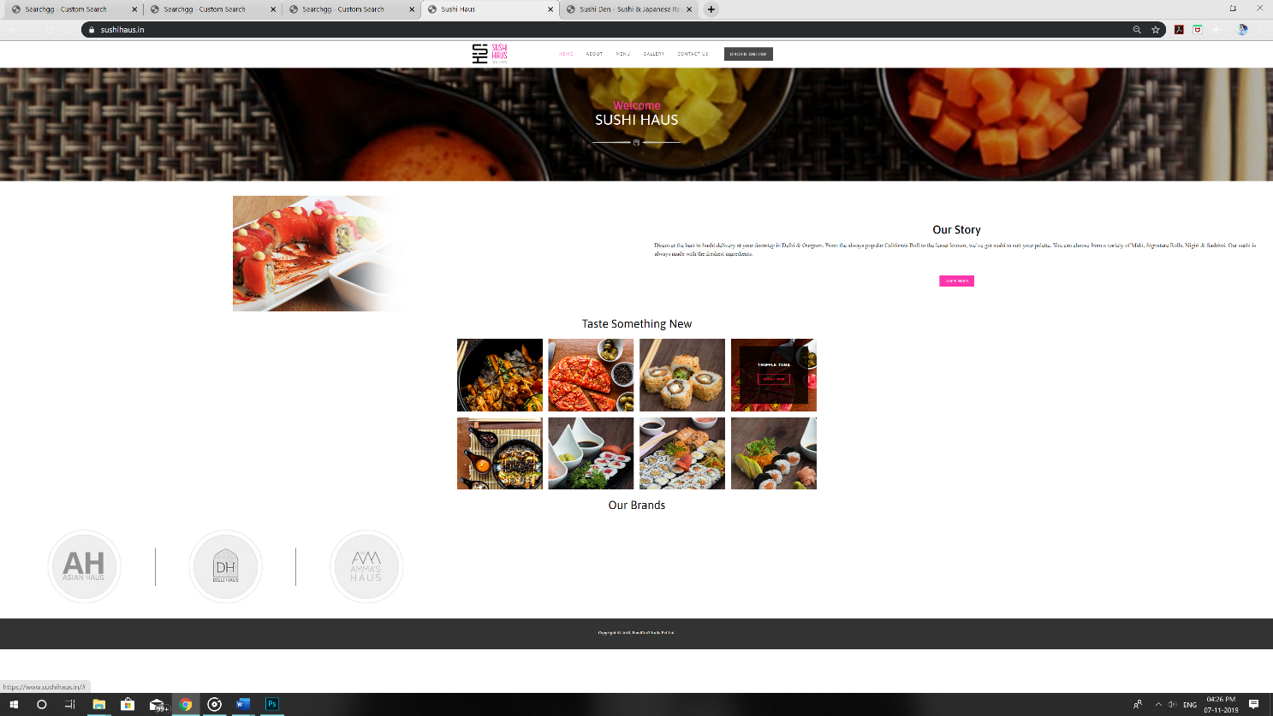

The home page is kept simple but with very few information. There is a lot of white spaces which is giving the feel of incompleteness. The alignment of the images and the logos are not proper. The font size is very small and quite difficult to read.

2.ABOUT US PAGE:

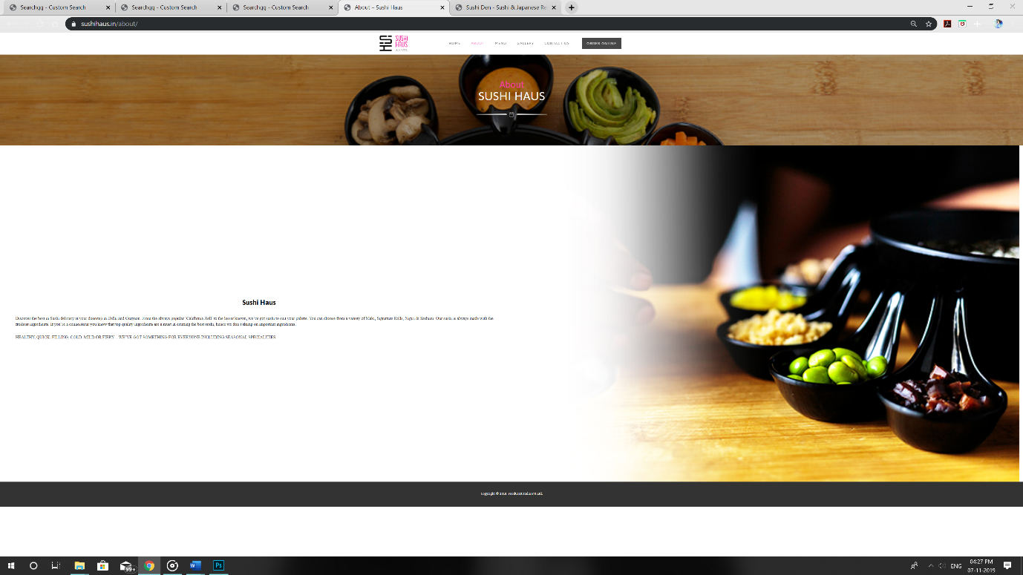

The about us page is again almost empty. There is no essential information regarding their policies or quality. A lot of white space is given and the proportion between the images and the text is not balanced. Even though the color’s used are pleasant on the eye they are not very definitive and they are not highlighting the content.

­­

3.MENU PAGE:

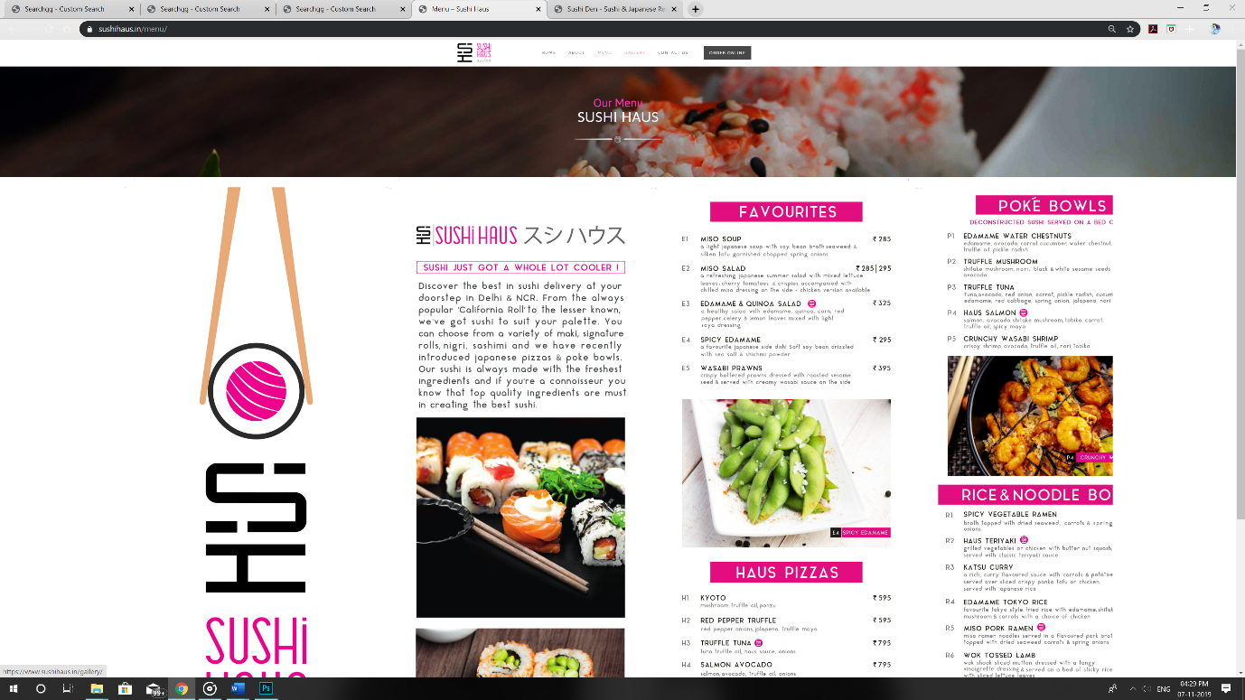

The menu page is cramped with information. The images are irrelevant to the mentioned dishes. The font size is very small and the ingredients are mentioned along with the name of the dish which is quite distractive. There is no consistency in the fonts that are used in the different pages.

4.GALLERY PAGE:

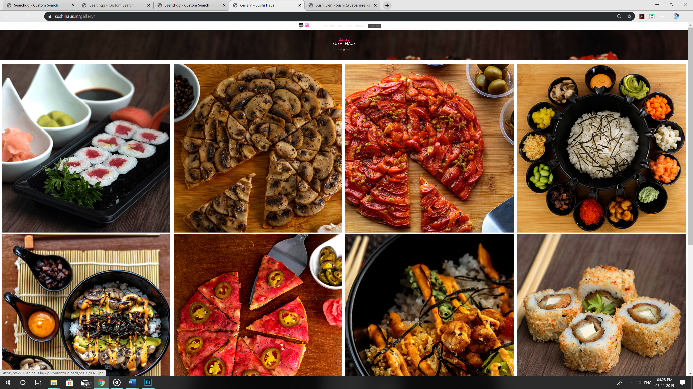

The gallery has pictures that are blown out of proportion when compared to the images in the other pages. There is no label on any of the pictures. There is no separation based on the cuisine. It is just listed in a random order. Customers who are new to trying sushi might not find it useful.

5.CONTACT US PAGE:

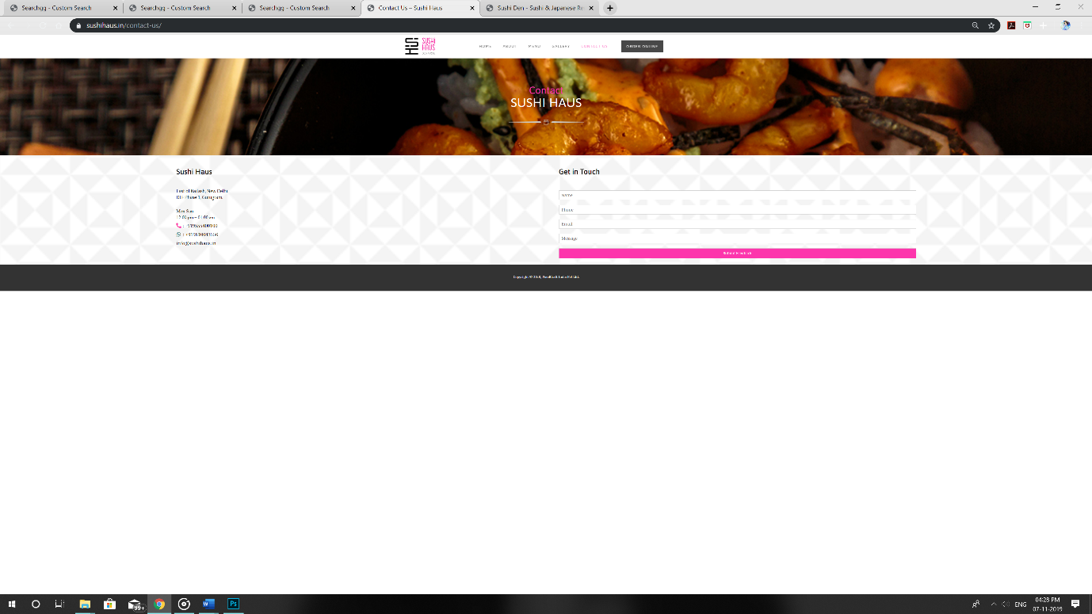

The contact page has the address listed on the left side and the sign-up form on the right. The patterns and the colors are placed properly which makes it look simple and nice.

Overall the website has not made efficient use of the space, the images that were used were mostly irrelevant to what they would want to highlight, the font size was way too small which will be difficult for most of the customers, and the arrangement of the text and images was all over the place.

These are the points that were taken in to account and worked on while designing the visual design for “Fresh of the boat”.